ESP8266 interfacing servo motor.

CODE:

#include <Servo.h>

Servo myservo; // Create a servo object

const int servoPin = 2; // Define the pin connected to the servo (D4 = GPIO 2)

void setup() {

myservo.attach(servoPin); // Attach the servo on D1 (GPIO 5) to the servo object

Serial.begin(115200); // Start serial communication at 115200 baud rate

}

void loop() {

// Move the servo to 0 degrees

myservo.write(0);

Serial.println("Servo at 0 degrees");

delay(1000); // Wait for 1 second

// Move the servo to 90 degrees

myservo.write(90);

Serial.println("Servo at 90 degrees");

delay(1000); // Wait for 1 second

// Move the servo to 180 degrees

myservo.write(180);

Serial.println("Servo at 360 degrees");

delay(1000); // Wait for 1 second

}

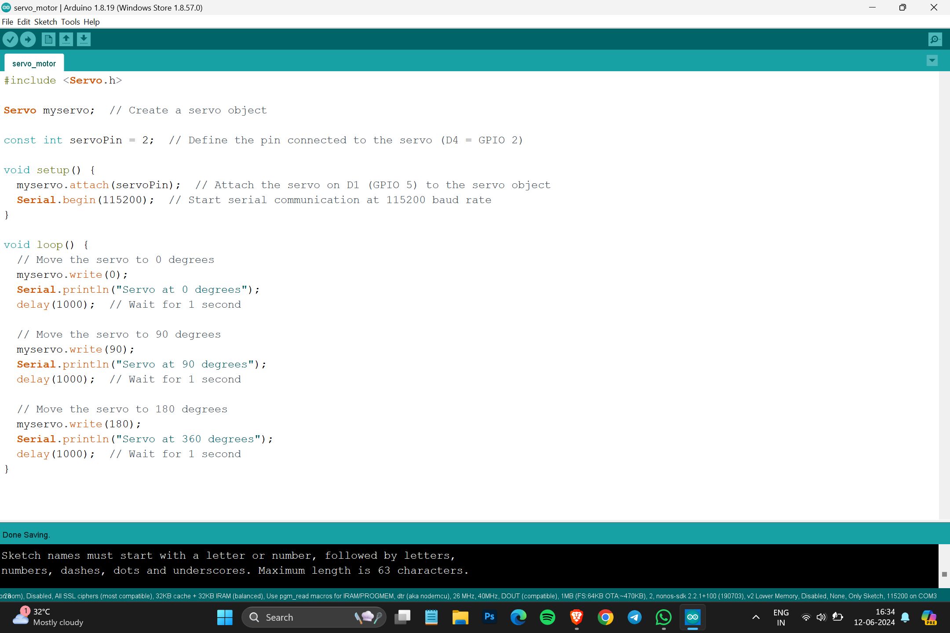

Result

